* Initial entities/Tables
  1. Department
  2. Student
  3. Mentor
* Relationships between entities
  1. Student belongs to department.
  2. Mentor belongs to department.
  3. Mentor has students.
* Draw ER diagram

DOB

SLname

SFname

SID

MLname

MFname

MID

m

n

Phone_no

Student

Year

have

Mentor

Address

n

n

Email

Department

Belong to

Belong to

1

1

course_id

Dnumber

course

Dname

* Final Tables

1. Department
2. Student
3. Mentor
4. Mentor has student

* Create statements
* To Create Database:-

CREATE DATABASE student_mentor;

USE student_mentor;

* To Create Tables:-

CREATE TABLE department(

`Dname` VARCHAR(45) NOT NULL,

`Dnumber` INT(11) NOT NULL,

` course_id` INT(11) NOT NULL,

` course` VARCHAR(45) NOT NULL,

PRIMARY KEY (`course_id`));

CREATE TABLE mentor(

`MID` INT(11) NOT NULL,

`MFname` VARCHAR(45) NOT NULL,

`MLname` VARCHAR(45) NOT NULL,

`Phone_no` VARCHAR(45) NOT NULL,

`Email` VARCHAR(45) NOT NULL,

`department_course_id` INT(11) NOT NULL,

PRIMARY KEY (`MID`),

FOREIGN KEY (`department_course_id`)

REFERENCES department(course_id);

CREATE TABLE student(

`SID` INT(11) NOT NULL,

`SFname` VARCHAR(45) NOT NULL,

`SLname` VARCHAR(45) NOT NULL,

`DOB` DATE NOT NULL,

`Year` VARCHAR(45) NOT NULL,

`Phone_no` INT(11) NULL DEFAULT NULL,

`Address` VARCHAR(45) NOT NULL,

`department_course_id` INT(11) NOT NULL,

PRIMARY KEY (SID),

FOREIGN KEY (department_course_id)

REFERENCES department(course_id);

CREATE TABLE student_has_mentor(

`student_SID` INT(11) NOT NULL,

`Mentor_MID` INT(11) NOT NULL,

`Remarks` VARCHAR(45) NOT NULL,

`Date` DATE NOT NULL,

`Description` VARCHAR(45) NOT NULL,

PRIMARY KEY (`student_SID`, `Mentor_MID`),

FOREIGN KEY (`Mentor_MID`)

REFERENCES mentor(MID)

FOREIGN KEY (student_SID)

REFERENCES student(SID);

* System generated E-R diagram

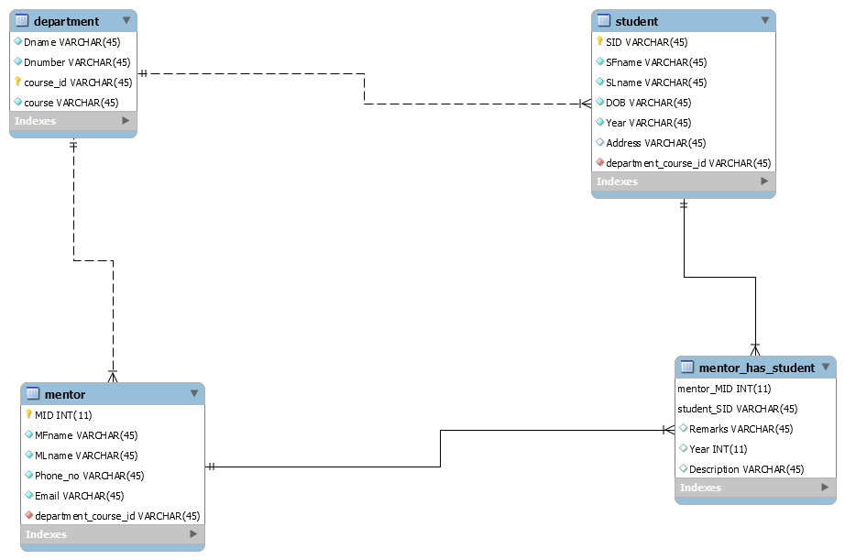

* Insert statement

Department table

insert into department values(‘Comp_Sci’,’CS-1’,’CS_101’,’Cyber security’);

insert into department values(‘Comp_Sci’,’CS-1’,’CS_102’,’Comp_network’);

Student table

insert into student values(‘102’,’Sinan’,’Bin’,1992-05-24,2015,’ABC’,’IT-102’);

insert into student values(‘1024’,’Arun’,’Singh’,1992-07-28,2006,’AAA’,’CS-102’);

Mentor table

insert into mentor values(‘1’,’Yadu’,’Krishnan_S’,9412165651,’yadukrishnan.s@alliance.edu.in’’ME-101’);

insert into mentor

values(‘2’,’Manjunath’,’SV’, 8650505642,’manjunath.sv@alliance.edu.in’’ECE-101’);

Mentor_has_Student table

insert into mentor_has_Student values(‘12’,’102’,’F-’,’2002’);

insert into mentor_has_Student values(‘8’,’1234’,’b+’,’2012’);